HVPARAMETERS function structure guide.

Function 'hvparameters' launches the parameter window called 'HVPARAMWIN'. This window is the figure related to the m-file 'HVPARAMWIN.m', hence modifications are to be performed on this m-file.

The file 'hvparameters.m' contains the help header for the function, detect if the parameter structure HV exists and detect if window 'HVCALIBRATEWIN' is opened. Window 'HVCALIBRATEWIN' and 'HVPARAMWIN' cannot be opened at the same time in order to avoid changing acquisition parameters while performing an acquisition.

The file 'HVPARAMWIN.m' contains the callbacks and functions related to the Graphical User Interface (GUI) of the parameter window. Its organisation is as follow:

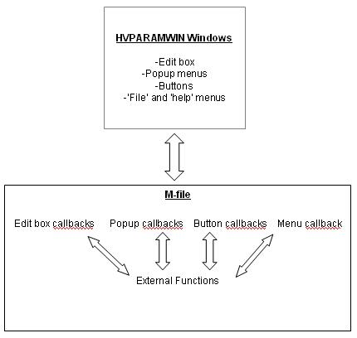

The code of 'HVPARAMWIN.m' is organised as the previous figure. Details of the code are given in the next pages:

BEGINNING OF CODE

% --- Executes just before HVPARAMWIN is made visible.
function HVPARAMWIN_OpeningFcn(hObject, eventdata, handles, varargin)

%------------------------------------------------------------------------
%========================================================================
%Following code corresponds to the callbacks of all edit boxes and popup
%menus.
%========================================================================
%------------------------------------------------------------------------
function edit1_Callback(hObject, eventdata, handles)
.
.
.
function edit16_Callback(hObject, eventdata, handles)

function popup1_Callback(hObject, eventdata, handles)
.
.
.
function popup16_Callback(hObject, eventdata, handles)

%------------------------------------------------------------------------
%========================================================================
%Following code corresponds to the callback of all buttons present in the
%interface
%========================================================================
%------------------------------------------------------------------------

% --- Executes on button press in DatAcqbutton.--------------------------
function DatAcqbutton_Callback(hObject, eventdata, handles)

% --- Executes on button press in FunGenbutton.--------------------------
function FunGenbutton_Callback(hObject, eventdata, handles)

% --- Executes on button press in Genbutton.-----------------------------
function Genbutton_Callback(hObject, eventdata, handles)

% --- Executes on button press in buttoncal---------------------------
function buttoncal_Callback(hObject, eventdata, handles)

%------------------------------------------------------------------------
%========================================================================
%Following code corresponds to the external functions used throughout
%the program
%========================================================================
%------------------------------------------------------------------------

function handles=listhandles(hObject, handles)
%function used to rename some handles with an increment which will allow
%the user to use them and increment them in loops, resulting in %significant reduction of coding lines.
%List of unit can be edited at the end of this function

function handles=visiblehandles(hObject, handles,a,b,c,d)
%This function is used to make visible text, edit boxes and popupmenu
%according to the active window.
%a=number of 'textname' to show, b=nb of 'textdes', c=nb of edit, d=nb of %popup.
function createlist(hObject,handles)
%This function create the list of parameters, descriptions and value that
%are to be shown in the corresponding window. This list is loaded %everytime the active window is changed. Using this function allow to %have clearer code within the callbacks of buttons and easily modify %parameters.

function editdata=checkedit(hObject,handles,editnumber,edittype)
%This function is used to check that the input data from the edit box is
%in correct format (edittype: 1=double;11=integer;2=string). A function %is used in order to prevent from typing this code under each edit-box %callbacks.

function assignvalue(hObject,handles,editnumber,value)
%This function assign the value entered in the edit box into the
%corresponding parameter. It is used as a function because these lines %have to be repeated for each callback of the edit boxes.

function val=defaultval()
%This function create a structure called HVDEFAULT where default values %of parameters will be saved. This structure will then be used if an %error occur while entering a data into an edit box: the parameter window %will then directly load the default value of the parameter. If default %values have to be changed, they will be changed in this function.

%------------------------------------------------------------------------
%========================================================================
%Following code corresponds to menu on top of the interface window
%========================================================================
%------------------------------------------------------------------------

%function used to load parameters from a .pas file
function loadpara_Callback(hObject, eventdata, handles)

%function used to load default parameters
function loaddefaultpara_Callback(hObject, eventdata, handles)

%function used to save the parameters into a .pas file
function savepara_Callback(hObject, eventdata, handles)

function file_Callback(hObject, eventdata, handles)

function help_Callback(hObject, eventdata, handles)

function exit_Callback(hObject, eventdata, handles)

function help1_Callback(hObject, eventdata, handles)

%put here a link to the help file in .pdf or .doc
%winopen('help.doc')

%function to be called when closing the window (via 'exit' or by closing %using the top right windows buttons
function closefcn(hObject, a, handles)

END OF CODE

